Atum Charge Admin Panel:

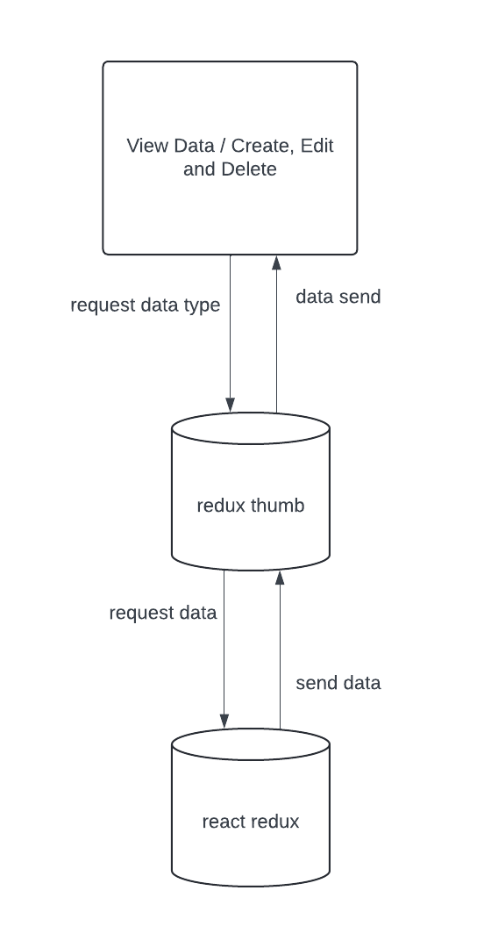

* Every page uses redux thumb actions to get data and redux thumb activates react redux action then data retrieved api call.

For Example: Admin Users Page.

* Get Admin List api - getAdminUsersList() to fetch data table and userRolesSlice() data types like pending, fulfilled(success) and rejected(failed/error).
* Delete user api - deleteUserAPI() to delete the selected user and deleteUserSlice() data types like pending, fulfilled(success) and rejected(failed/error).
* Edit user api - editUserByIdAPI() to edit the selected user details and editUserSlice() data types like pending, fulfilled(success) and rejected (failed/error).
* View user api - getUserByIdAPI() to view the selected user details and getUserByIdSlice() data types like pending, fulfilled(success) and rejected (failed/error).